In the Way of Mary
For Teenagers and Young Adults

1 - John Claude ’s Early Life

Introduction
Close your eyes

Breath in your nose and out through your mouth.
Breath in your nose and out through your mouth.
Repeat 7 times…

Sign of the Cross
In the Name of the Father, and of the Son, and of the Holy Spirit. Amen.

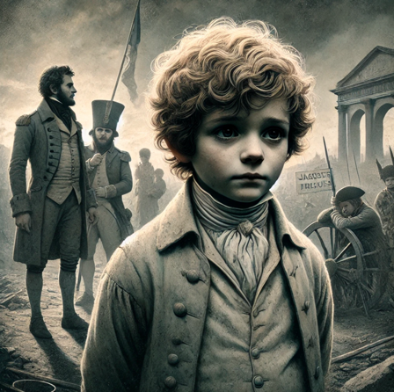
Story
Jean-Claude was born at the time of the French revolution in 1790. Sadly, Jean-Claude was only five years old when his parents passed away within weeks of each other, leaving him orphaned in a turbulent time of the French Revolution. His father, Jacques, had faced persecution for protecting a non-revolutionary priest, hiding him from French revolutionary authorities. Young Jean-Claude, shaped by these early losses, grew up in a world where faith had to weather challenges. From these sorrows, he learned resilience and turned to God for comfort. These experiences laid the foundation for his later dedication to prayer and trust in divine guidance through hardship.

As a young boy in Saint-Bonnet-le-Troncy, Jean-Claude Colin found solace in nature, often retreating to the quiet of the nearby woods. In these moments alone, he would gaze at the trees and fields, feeling a profound sense of connection with God. Though still shy and reserved, he would close his eyes and say his prayers, imagining the presence of Mary by his side. These experiences, away from the busyness of village life, laid the foundation for his deep, contemplative spirituality. In later years, he would recall these moments as some of his first encounters with God’s peace and presence in alone in the
forest.

Silence
Sit still for 1 minute. What parts of this story stays with you?

Discuss
Any thoughts? 2-3 minutes

Common Prayer
What do you want to thank God for?
What do you wish to place in God's hands?
How would you like God’s guidance or support in your life?

Hail Mary
We pray with Mary at this time:
Hail Mary, full of grace, the Lord is with thee;
Blessed art thou among women,
and blessed is the fruit of thy womb, Jesus.
Holy Mary, Mother of God,
pray for us sinners,
now and at the hour of our death.
Amen.

Closing Prayer
Loving God, we come to You with hearts grateful for the life of Jean-Claude Colin, who, as a young child, faced the profound loss of his parents in a time of great turmoil. Left orphaned amidst the challenges of the French Revolution, Jean-Claude found strength in his faith and comfort in Your presence, learning early on to turn to You in his sorrow. In the quiet of nature, he sought refuge, drawing close to Mary and building a life rooted in prayer and trust. May his resilience inspire us to lean on You through our own struggles, finding peace in solitude, courage in hardship, and guidance in prayer. Grant us the grace to trust in Your loving presence, just as Jean-Claude did, and to carry forward his legacy of quiet strength and unwavering faith. Amen.

Sign of the Cross
In the Name of the Father, and of the Son, and of the Holy Spirit. Amen.

