In the Way of Mary
For Teenagers and Young Adults

4 - Born at a difficult time

Introduction
Close your eyes

Breath in your nose and out through your mouth.
Breath in your nose and out through your mouth.
Repeat 7 times…

Sign of the Cross
In the Name of the Father, and of the Son, and of the Holy Spirit. Amen.

Story

Over two hundred years ago in France - on August 29 1786 - a baby girl was born to Theodore Chavoin and his young wife, Jeanne. They called their daughter Jeanne-Marie. No one knew it then but she was to do something very special with her life.

When Jeanne-Marie was only four years old there was terrible trouble across the country of France. History books now refer to that event as the French Revolution because it was as if life in France was turned upside down.

A new government took over and people who once had power were now hunted down and many were killed. There was much hatred and violence even against the Catholic Church. All priests were expected to take an oath of loyalty - not to God or the Pope, but to the government. Those who refused were in danger of losing their lives.

In the small village of Coutouvre in France where the Chavoin family lived no one was killed or hurt but their parish priest. Fr Guillermet, was a very good man and did not wont to take the oath - so he. was arrested and forced to leave. the. country instead. The people would toke it in turns to offer their home for secret Masses to be said by other faithful priests and to hide the sacred vessels. The Chavoins did this too.

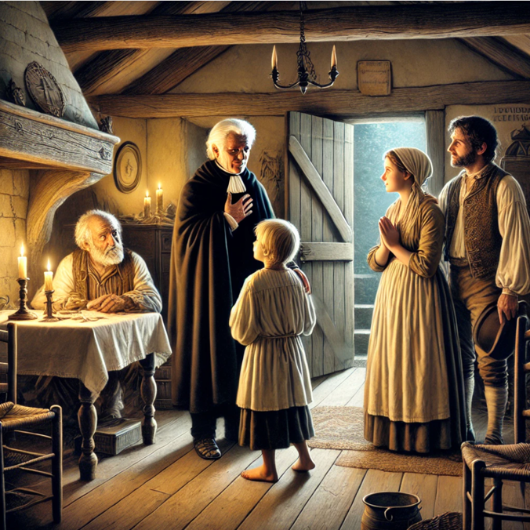
One day a priest in need of help came to Coutouvre. He was very frightened and distressed. He had taken the oath to the government but now he was sorry he had done so. No one would have anything to do with him - the faithful Catholics were ashamed of him and those who were on the side of the government would have handed him over to them. He had to find somewhere to hide. It was the Chavoin family who decided to care for Monsieur Alex. They took him into their home and so Jeanne-Marie and her sister learned to show kindness to people whom no one else would help.

Silence
Sit still for 1 minute. What parts of this story stays with you?

Discuss
Any thoughts? 2-3 minutes

Common Prayer
What do you want to thank God for?
What do you wish to place in God's hands?
How would you like God’s guidance or support in your life?

Hail Mary
We pray with Mary at this time:
Hail Mary, full of grace, the Lord is with thee;
Blessed art thou among women,
and blessed is the fruit of thy womb, Jesus.
Holy Mary, Mother of God,
pray for us sinners,
now and at the hour of our death.
Amen.

Closing Prayer
Loving God, we give thanks for the life and faith of the Chavoin family, who, despite the terror and fear of the French Revolution, responded with courage, care, and compassion. Through their bravery, humility, and unwavering devotion to You, they showed us the beauty of a life lived for others. May their example inspire us to serve with open hearts and compassionate hands toward those in need. May we find strength in quiet faith, always seeking to bring Your love to others. Guide us to follow their path of dedication, unity, and love.

Amen.

Sign of the Cross
In the Name of the Father, and of the Son, and of the Holy Spirit. Amen.

