In the Way of Mary
For Teenagers and Young Adults

5 - Growing up

Introduction
Close your eyes

Breath in your nose and out through your mouth.
Breath in your nose and out through your mouth.
Repeat 7 times…

Sign of the Cross
In the Name of the Father, and of the Son, and of the Holy Spirit. Amen.

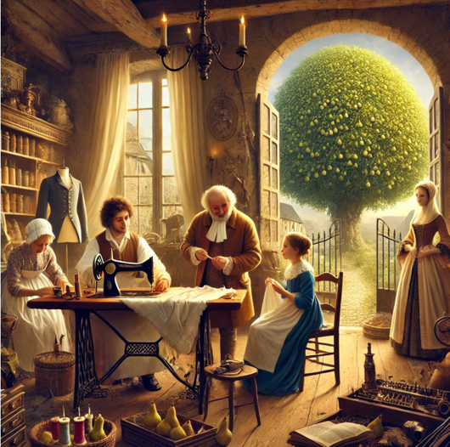
Story
In the early 1800s France, Jeanne-Marie Chavoin’s father was a tailor, and his workroom was in the family home. All his customers would come to see him—probably through the back gate by the pear tree that grew there. Since Jeanne-Marie did not go to school, she did all her learning at home. She learned about people because so many came to the shop to order new clothes. Through their conversations, she learned about the ups and downs in their lives. From her father, she learned all about sewing, how to deal with customers, how to read and write, and how to keep the account books. From her mother, she learned how to manage the house, cook, grow vegetables, and care for sick people. From the priest who lived with the Chavoins, she probably learned a lot about the history of her country.

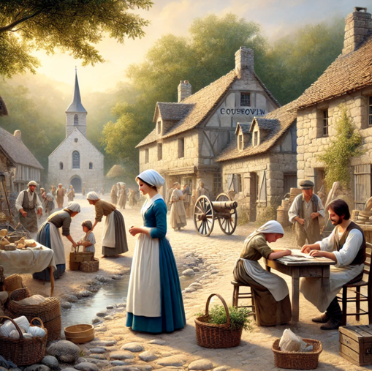
Most of all, Jeanne-Marie liked learning about God. At home, she prayed with her family and attended the parish church. When she was nine or ten, the old parish priest returned to Coutouvre, France. He prepared Jeanne-Marie and other children to receive their First Holy Communion and Confirmation. Jeanne-Marie enjoyed these lessons so much that, as she grew older, she helped Father Guillermet give catechism classes to younger children.

Coutouvre was an open and friendly place to live, with plenty of people to meet. Jeanne-Marie was a great support to her family in the shop, in the home, and in the fields where they grew crops. She liked helping pe ople, especially when no one else showed an interest. She knew everyone in the village and always noticed if there seemed to be a problem in one of the families. She would try to support them, often visiting the sick—even going to see a young girl who suffered from an illness that frightened others. She also assisted Father Guillermet in caring for the church. And all this she did in such a way that she did not draw attention to herself.

Silence
Sit still for 1 minute. What parts of this story stays with you?

Discuss
Any thoughts? 2-3 minutes

Common Prayer
What do you want to thank God for?
What do you wish to place in God's hands?
How would you like God’s guidance or support in your life?

Hail Mary
We pray with Mary at this time:
Hail Mary, full of grace, the Lord is with thee;
Blessed art thou among women,
and blessed is the fruit of thy womb, Jesus.
Holy Mary, Mother of God,
pray for us sinners,
now and at the hour of our death.
Amen.

Closing Prayer
Loving God, we thank You for the example of Jeanne-Marie Chavoin, whose life reminds us of the beauty in humble service and quiet devotion. As she learned from her family, her community, and her faith, may we too open our hearts to Your teachings in the everyday moments of life. Help us to see and respond to the needs of those around us, offering support with compassion and humility. May we, like Jeanne-Marie, find joy in serving others without seeking recognition, trusting that through our small acts of love, we reflect Your greater glory.

Amen.

Sign of the Cross
In the Name of the Father, and of the Son, and of the Holy Spirit. Amen.

