Marist Way - Prayer One

Breathe
Close your eyes.
Breathe in through your nose and out through your mouth.
Breathe in through your nose and out through your mouth.
Repeat x 10

Bell and Candle
As we ring our bell and light our candles we pray that God is with us.

Sign of the Cross
In the name of the Father, and of the Son, and of the Holy Spirit. Amen.

Opening Reading
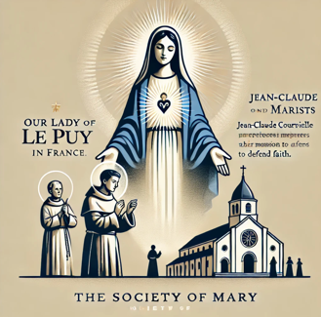
Let the first idea of the Society of Mary come from Our Lady of Le Puy in France. The first one to whom the idea was given was a Jean-Claude Courveille. In 1812, while renewing his promise to Mary, he heard, not with his bodily ears, but with those of the heart, interiorly but very distinctly: “Here… is what I want. I have always initiated my Divine Son in everything. I followed him to Calvary itself, standing at the foot of the Cross when He gave His life for man’s salvation. Now, in heaven, sharing His glory, I follow his path still, in the work He does for His Church on earth. Of this Church, I am the Protectress. I am like a powerful army, defending and saving souls. When a fearful heresy threatened of convulse the whole of Europe, my son raised up His servant, Ignatius, to form a Society under His name, calling itself the Society of Jesus, with members called Jesuits, to fight against the hell unleashed against His church. In the same way, in this last age of impiety and unbelief, it is my wish, and the wish of my Son, that there be another Society to battle against hell, one consecrated to me, one which will have my name, which will call itself the Society of Mary, whose members will call themselves Marists.” – OM II doc 718.

First Reading - Ecclesiasticus 1:1-10
Before all other things, wisdom was created
All wisdom is from the Lord,
and it is his own for ever.
The sand of the sea and the raindrops,
and the days of eternity, who can assess them?
The height of the sky and the breadth of the earth,
and the depth of the abyss, who can probe them?
Before all other things wisdom was created,
shrewd understanding is everlasting.
For whom has the root of wisdom ever been uncovered?
Her resourceful ways, who knows them?
One only is wise, terrible indeed,
seated on his throne, the Lord.
He himself has created her, looked on her and assessed her,
and poured her out on all his works
to be with all mankind as his gift,
and he conveyed her to those who love him.
The Word of the Lord

Response - Thanks be to God.

Today’s Gospel - Mark 9:14-29
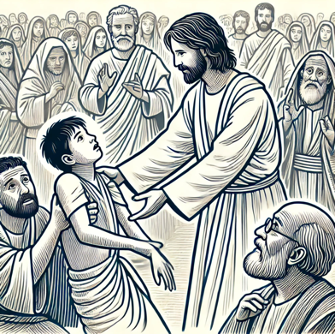
When Jesus, with Peter, James and John came down from the mountain and rejoined the disciples, they saw a large crowd round them and some scribes arguing with them. The moment they saw him the whole crowd were struck with amazement and ran to greet him. ‘What are you arguing about with them?’ he asked. A man answered him from the crowd, ‘Master, I have brought my son to you; there is a spirit of dumbness in him, and when it takes hold of him it throws him to the ground, and he foams at the mouth and grinds his teeth and goes rigid. And I asked your disciples to cast it out and they were unable to.’ ‘You faithless generation’ he said to them in reply. ‘How much longer must I be with you? How much longer must I put up with you? Bring him to me.’ They brought the boy to him, and as soon as the spirit saw Jesus it threw the boy into convulsions, and he fell to the ground and lay writhing there, foaming at the mouth. Jesus asked the father, ‘How long has this been happening to him?’ ‘From childhood,’ he replied ‘and it has often thrown him into the fire and into the water, in order to destroy him. But if you can do anything, have pity on us and help us.’ ‘If you can?’ retorted Jesus. ‘Everything is possible for anyone who has faith.’ Immediately the father of the boy cried out, ‘I do have faith. Help the little faith I have!’ And when Jesus saw how many people were pressing round him, he rebuked the unclean spirit. ‘Deaf and dumb spirit,’ he said ‘I command you: come out of him and never enter him again.’ Then throwing the boy into violent convulsions it came out shouting, and the boy lay there so like a corpse that most of them said, ‘He is dead.’ But Jesus took him by the hand and helped him up, and he was able to stand. When he had gone indoors his disciples asked him privately, ‘Why were we unable to cast it out?’ ‘This is the kind’ he answered ‘that can only be driven out by prayer.’
The Gospel of the Lord.

Response - Praise to you Lord Jesus Christ.

Questions for discussion then journaling
- What is staying with you from the First Reading or the Gospel?
- Jean-Claude Courveille “heard with the ears of the heart.” Listening is an important part of the Marist way. How do we listen?
- The Society of Mary was created to bring people closer to God in a time when many had forgotten about faith. How does the Marist Way speak to us today?
- The Marists are called to be humble, helpful, and loving—just like Mary. How have you seen this in other people in your own life?
- Jean-Claude Courveille was the first person to hear Mary speak about the society of Mary. He soon shared this with other seminarians. If someone shared this story with you today, what would you think? What do you think people like Marcellin Champagnat and John Claude Colin reacted with acceptance?

Discussion for 10 minutes.

Common Prayer
The response to the prayer is “Lord hear us”….. “Lord hear our prayer”
- As we discern the Marist way in our lives, we invite Mary’s presence to guide us. Fill us with your Spirit so that we may become your hands, feet, and heart. Lord, hear us.
- We pray for the sick at this time, especially Pope Francis and others whom we now call to mind... (Pause for 10 seconds) Jesus, pour out your healing touch upon them.
- We pray for the parts of our world where there is conflict—conflict in our homes, conflict in our families, division among friends, and violence among nations, especially in Ukraine, Gaza, and Burma. Inspire leaders to use the words, “I forgive you.” Lord, hear us.
- Are there any other prayers?

Journaling….
While the following songs play, you are invited to journal some of your thoughts, questions or issues that are rising to the surface……..
- How Deep The Fathers Love For Us - Austin Stone
- Breath of Heaven - Amy Grant
- Dare to Dream - Mary Sisters

Final Prayer
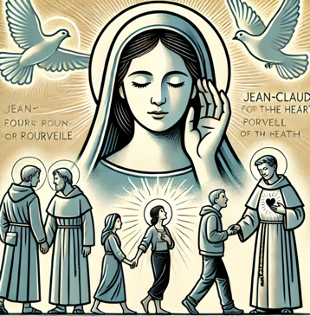
Loving God, as we journey in the Marist way, we place ourselves under Mary’s gentle guidance, trusting in her wisdom and love. Like Jean-Claude Courveille, may we learn to listen with the ears of the heart, discerning Your call in our lives. Fill us with faith, humility, and courage to be Your presence in the world—serving with compassion, standing with the poor, and seeking peace where there is division. May we always turn to You in prayer, knowing that through You, all things are possible. Strengthen us to walk in Mary’s footsteps, bringing hope and love to those in need. Amen.

